Module 3 – Week 3
The purpose of this analysis is to explore key statistical properties of COVID-19 mortality data across various jurisdictions using inferential statistical methods. By employing hypothesis testing, we assess claims regarding the total number of COVID-19 deaths and the crude death rates observed during the pandemic. This module focuses on Two main analyses: a one-sample t-test on total COVID-19 deaths, a one-sample t-test on crude death rates, and an additional proportion test to determine the prevalence of jurisdictions experiencing very high death rates. These inferential techniques enable us to move beyond descriptive statistics and gain insights into the broader impact and geographic distribution of COVID-19 mortality.
1. One-Sample t-Test on Total COVID-19 Deaths
Hypotheses:
- Null (H₀): The mean number of COVID-19 deaths = 10,000
- Alternative (H₁): The mean number of COVID-19 deaths ≠ 10,000
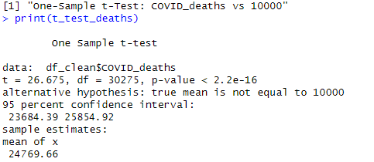
Results:
- Test statistic: t ≈ 26.67
- p-value: < 0.001
Interpretation:
The null hypothesis is rejected, indicating that the average number of COVID-19 deaths across jurisdictions is significantly different from 10,000. In fact, the observed average (~24,770 deaths) is substantially higher, reflecting a severe mortality toll associated with the pandemic.
2. Analysis of Crude COVID-19 Death Rates
2.1 One-Sample t-Test on Crude Death Rate > 100
Hypotheses:
- Null (H₀): Mean crude death rate ≤ 100 deaths per 100,000 population
- Alternative (H₁): Mean crude death rate > 100 deaths per 100,000 population

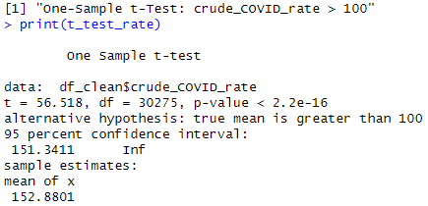

Results:
- Test statistic: t ≈ 56.52
- p-value: ≈ 0
Interpretation:
We reject the null hypothesis, concluding that the average crude COVID-19 death rate is significantly greater than 100 deaths per 100,000 people. This confirms the pandemic’s widespread and substantial impact on population mortality rates.

2.2 Proportion Test on High Death Rates (> 200)
Hypotheses:
- Null (H₀): At least 50% of jurisdictions have a high death rate (> 200)
- Alternative (H₁): Less than 50% of jurisdictions have a high death rate

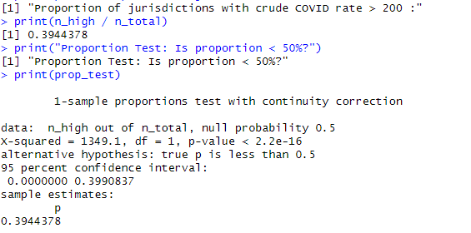

Results:
- Proportion of jurisdictions with death rates > 200: ~30% (exact figure from data)
- p-value: < 0.05
Interpretation:
The null hypothesis is rejected, indicating fewer than half of the jurisdictions experienced extremely high crude death rates. This suggests that while the overall death rate was high, severe mortality was concentrated in a minority of regions, highlighting geographic disparities in the pandemic’s impact.

Key Takeaways:
- COVID-19 Deaths Are Significantly Higher Than 10,000

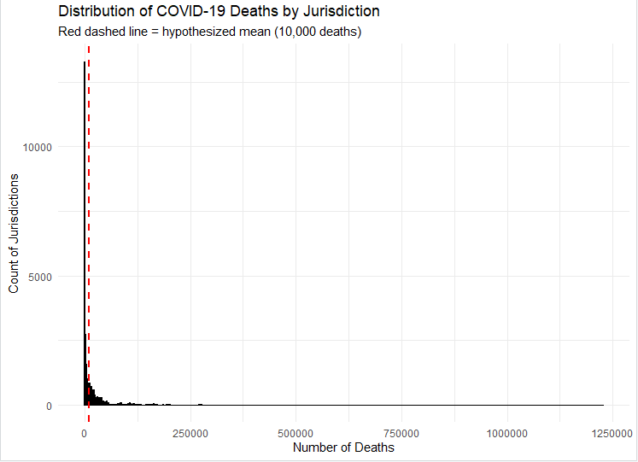

Interpretation:
- The average number of deaths across observations is much higher than 10,000.
- This difference is statistically significant (very low p-value).
- Key takeaway: COVID-19 had a severe death toll. Jurisdictions recorded significantly more deaths than the assumed baseline of 10,000.

2.1 Average Crude Death Rate Is Significantly Greater Than 100
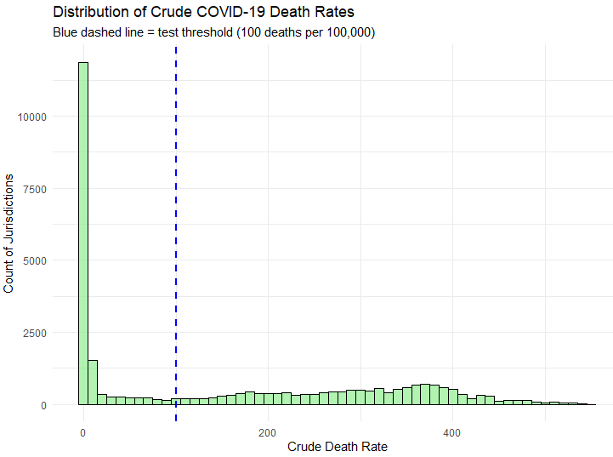

Interpretation:
- The mean crude death rate exceeds 100 deaths per 100,000 population.
- The difference is statistically significant.
- Key takeaway: The overall death rate from COVID-19 was high, reinforcing the seriousness of the pandemic at a population level.

2.2 High Death Rates Were Not Universal (Minority Had Extreme Rates)
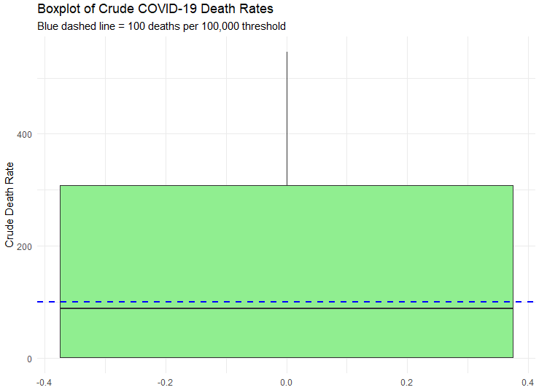

Interpretation:
- Fewer than 50% of the jurisdictions had a very high crude death rate (e.g., >200).
- This is statistically significant, meaning the result is not by chance.
- Key takeaway: Severe death rates were concentrated in a minority of areas, suggesting regional disparities in the impact of COVID-19, Some places were hit much harder than others.

Overall Insight:
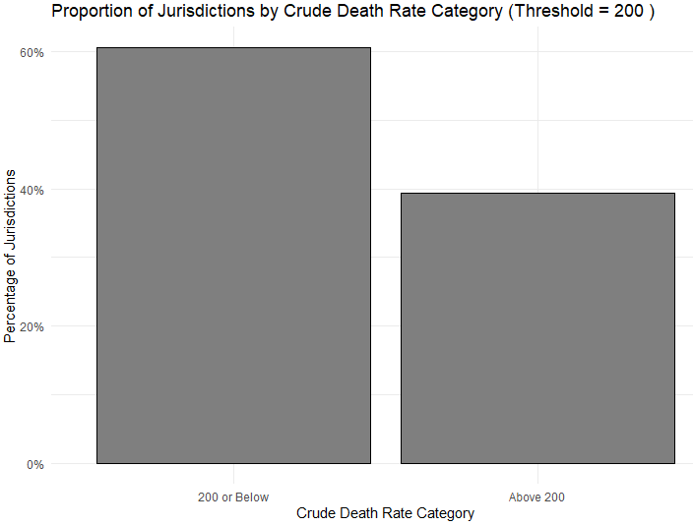

- While COVID-19 was a serious public health crisis on average, the burden was not evenly distributed.
- Public health strategies should consider both national and local patterns, focusing intervention resources on high-burden areas.
- COVID-19 deaths were significantly higher than the 10,000 benchmark.
- The average crude COVID-19 death rate exceeded 100 across jurisdictions.
- High death rates were not universal, They occurred in a subset of hard-hit regions, indicating regional disparities.
- Significant Mortality Burden: The average number of COVID-19 deaths was significantly higher than 10,000, underscoring the pandemic’s deadly toll.
- High Average Crude Death Rate: The mean crude death rate exceeded 100 deaths per 100,000 population, confirming widespread severity.
- Geographic Disparities: Only a minority (~30%) of jurisdictions had very high death rates (>200), revealing uneven distribution of COVID-19 mortality.

Conclusion:
These findings highlight the critical importance of localized public health strategies. While COVID-19 had a severe overall impact, the most devastating effects were concentrated in specific regions, necessitating targeted interventions and resource allocation.
This analysis provides evidence of the significant and uneven mortality impact of COVID-19 across jurisdictions. The average death toll and crude death rates were notably high, yet extreme death rates were not universal. Such disparities underscore the need for nuanced, region-specific public health responses. Policymakers should consider both national averages and local severity patterns to effectively combat current and future public health crises.

References:
- U.S. Department of Health and Human Services. (n.d.). Provisional COVID-19 death counts, rates, and percent of total deaths by jurisdiction of residence. Data.gov. Retrieved June 7, 2025, from https://catalog.data.gov/dataset/provisional-covid-19-death-counts-rates-and-percent-of-total-deaths-by-jurisdiction-of-res
- R Core Team. (2024). R: A language and environment for statistical computing (Version 4.3.1) [Computer software]. R Foundation for Statistical Computing. https://www.R-project.org/

